Name- Alankrit Sajwan
College- Vellore Institute of Technology, Bhopal
Reg No: 25BAI10512
PROJECT REPORT
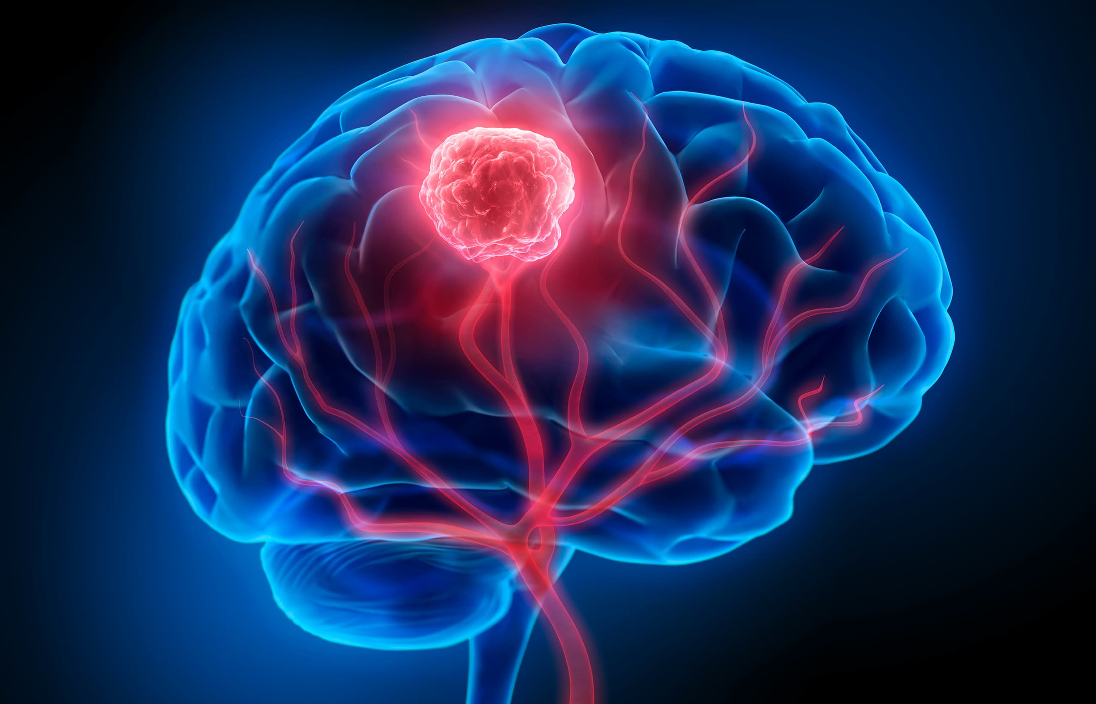
BRAIN TUMOR CLASSIFICATION
1. Introduction 3
2. Problem Statement 3
3. Functional Requirements 4
3.1 Module 1: Data Ingestion & Preprocessing 4
3.2 Module 2: Multi-Model Training Engine 4
3.3 Module 3: Evaluation & Visualization 5
4. Non-Functional Requirements 5
5. System Architecture 5
6. Implementation Details 6
Tools & Libraries: 6
Key Algorithms: 7
7. Results and Analysis 7
7.1 Model Performance Comparison 7
7.2 Visualization 7
7.3 Efficiency 9
7.4 Conclusion 9
8. Testing Approach 9
9. Challenges Faced 10
10. Future Enchancements 10
11. Learnings & Key Takeaways 11
12. References 13

1. Introduction
Q. What is the significance of Brain Tumor Classification?
A brain tumor refers to a swelling or growth of atypical cells in the brain. It is vital to identify brain tumors as quickly and accurately as possible to organize treatment, which can improve the patient's chance of survival. Magnetic Resonance Imaging (MRI) is the most frequently used approach for identifying brain tumors; however, the current procedure for analyzing MRI scans involves a lengthy manual process, requires expertise from radiologists who are short in supply, and suffers from human error.
This process is challenging and is the motivation for the project that uses Deep Learning with Transfer Learning. Rather than designing a neural net from scratch, we use a pre-trained architecture (VGG16 and ResNet50) that has already been trained to recognize features in images. In this case, the system will automate the diagnosis by classifying MRI scans into one of four output classes: Glioma Tumor, Meningioma Tumor, Pituitary Tumor, or No Tumor.

2. Problem Statement
The primary obstacle in medical image diagnosis is the variability and complexity of MRI scans. Tumors can vary significantly in size, shape, and location.
The Constraints:
- Subjectivity: Different radiologists might have differing interpretations of the same scan.
- Efficiency: The manual screening method is a time-consuming process and could delay treatments.
- Data Scarcity: Training deep learning models from scratch requires thousands of annotated medical images, which are difficult to get.

Objective:
This project intends to develop a robust automated classification system that takes raw MRI images and outputs the tumor type with a reasonable degree of accuracy. By comparing two powerful architectures, VGG16 and ResNet50, we seek to identify which architecture will perform best in terms of medical feature extraction for this specific dataset.

3. Functional Requirements
The system is built around three major functional modules:
3.1 Module 1: Data Ingestion & Preprocessing
- Input: The system accepts a compressed dataset (Brain-tumor-classification.zip) containing MRI images organized by class folders.
- Processing:
  - It utilizes the zip file and os libraries to extract data into the Google Collab environment.
  - It employs Image Data Generator for normalization (rescaling pixel values to 0-1).
  - It applies Data Augmentation (rotation, width/height shifts, zooming, and flipping) to artificially increase the diversity of the training data and prevent overfitting.
  - It splits the data into Training (80%) and Validation (20%) subsets.

3.2 Module 2: Multi-Model Transfer Learning Engine
- Workflow: The system initializes two distinct Convolutional Neural Networks (CNNs) using Transfer Learning:
- VGG16: A 16-layer network known for its simplicity and depth. We utilize weights pre-trained on the Image Net dataset.
- ResNet50: A 50-layer Residual Network that uses "skip connections" to solve the vanishing gradient problem in deep networks.
- Operation: To maintain the ability to extract features, the pre-trained layers are "frozen" (trainable=False). On top of the pre-trained layers, custom fully connected layers are constructed:
  - GlobalAveragePooling2D
  - Dense layer (128 units, ReLU activation)
  - Output Dense layer (4 units, Softmax activation to perform multi-class classification).
3.3 Module 3: Evaluation & Visualization
- Metrics: The system calculates Categorical Cross entropy Loss and Accuracy.
- Output: It generates comparative line graphs using matplotlib to visualize Training vs. Validation Accuracy over epochs.
4. Non-Functional Requirements
- Accuracy: The model must provide a classification accuracy better than random guessing (25%) to be viable.
- Performance: The system leverages GPU acceleration (via Google Collab) to ensure training completes within a reasonable timeframe (under 20 minutes for 30 epochs).
- Reproducibility: The code utilizes fixed batch sizes (32) and specific image target sizes (224x224) to ensure consistent results across runs.

5. System Architecture
The project uses a Pipeline Architecture comprising of:
- Data Layer: This includes the use of flow from directory to extract the .zip and subsequent directory flow.
- Processing Layer: TensorFlow/Kera’s handles the tensor transformations and model training.
- Presentation Layer: Matplotlib provides the visual performance history.
(Conceptual Diagram Description): User uploads Zip -> Colab extracts -> Augmentation -> VGG16/ResNet50 Feature Extractor -> Softmax Classifier -> Prediction)
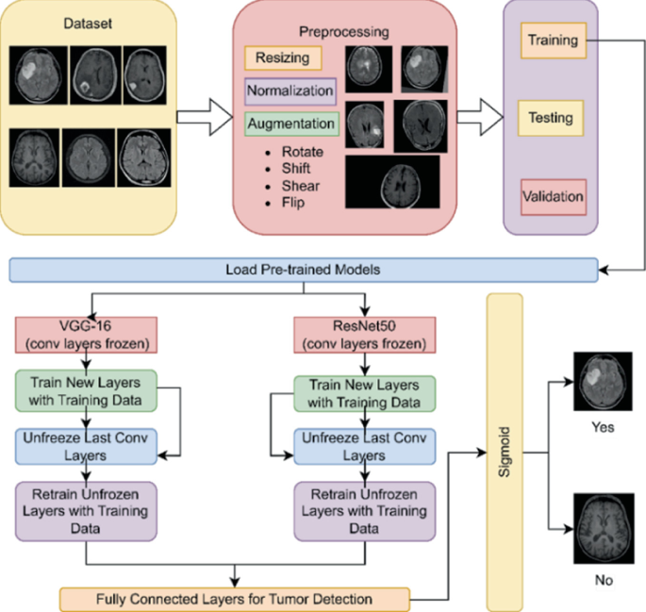

6. Implementation Details
Tools & Libraries:
- Python: Core programming language.
- TensorFlow / Kera’s: For building and training the deep learning models.
- Matplotlib: For plotting accuracy graphs.
- Google Colab: Cloud development environment.

Key Algorithms:
- VGG16: Selected for its consistent architecture that often performs well on medical images when texture matters.
- ResNet50: Chosen to test if a deeper network with residual connections could capture more complex features of the tumors.
7. Results & Analysis
To find the best predictor, I trained both models on the same augmented dataset. VGG16 was trained for 20 epochs, and ResNet50 for 30 epochs.
7.1 Model Performance Comparison
After training, both models were evaluated on the validation set.
Model Name | Loss (Lower is better) | Accuracy (Higher is better)
VGG16 | 1.022 | 55.13%
ResNet50 | 1.297 | 39.74%

7.2 Visualization
The training history plots revealed distinct behaviors:
- VGG16: Exhibited a consistent increase in training accuracy (reaching ~71%), while validation accuracy fluctuated throughout the training process and ended around 55%. This indicates that the model learned the features reasonably well but had a slight generalization problem on this run.
- ResNet50: Struggled to converge effectively, with accuracy hovering around 39-40%. This indicates that the deeper architecture might require more data or "unfreezing" of layers to adapt to the medical domain.

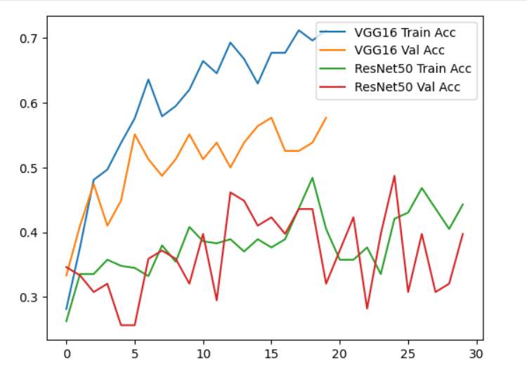

7.3 Efficiency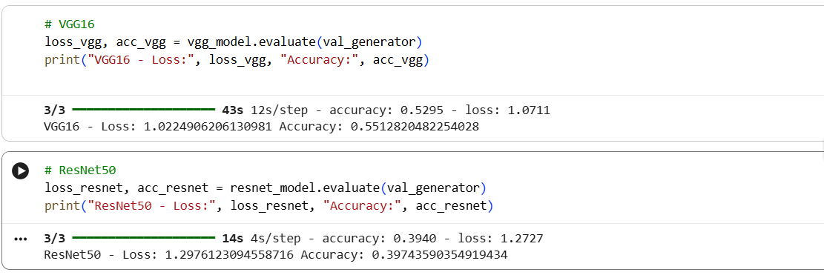

7.4 Conclusion
Based on the comparative review, the VGG16 model emerges as the more preferable model for this particular implementation. While Resnet50 is a "deeper" and more modern model, the feature extraction of VGG16 was much simpler and proved to work better on such a limited and specific dataset like the MRI's used in the project.

8. Testing Approach
- Validation Split: I utilized Keras validation split=0.2 within the Image Data Generator. This ensured that 20% of the training data was held back and never shown to the model during the learning phase.
- Metric Evaluation: The model evaluate() function was called at the end of the script to provide an unbiased report of the Loss and Accuracy on unseen data.

9. Challenges Faced
- Data Imbalance/scarcity: The accuracy levels (55% and 40%) suggest the dataset is challenging. Medical images often have subtle differences between classes (e.g., Glioma vs. Meningioma).
- Overfitting: The VGG16 model achieved ~71% training accuracy but only ~55% validation accuracy. This gap indicates overfitting, which I attempted to mitigate using Data Augmentation (rotation, zoom).
- Environment Constraints: Loading large datasets in cloud environments required careful handling of file paths and unzipping processes.

10. Future Enhancements
To improve the system further, I would implement the following:
1.Fine-Tuning: Instead of freezing all pre-trained layers, I would unfreeze the top 20 layers of the base models and re-train them with a very low learning rate. This usually improves accuracy significantly in medical imaging.
2.Advanced Architectures: I would experiment with DenseNet121 or EfficientNet, which are known to be highly efficient for image classification tasks.
3.Web Interface: Wrap the best-performing model (VGG16) in a Streamlit or Flask web app, allowing a doctor to upload a JPEG/PNG of an MRI and get an instant prediction.

11.Learning and Takeaways
This project yielded some useful findings about the real-world application of Deep Learning in medical diagnostics. Here are some key technical and methodological learnings:
- Architecture Complexity vs. Performance:
The assumption that "deeper is better" was not always the case. The shallower VGG16 architecture (55% accuracy) performed substantially better than the deeper ResNet50 (39% accuracy) model for this dataset. It became evident, particularly for a smaller and specialized dataset (MRI scans), that ResNet's complex architecture risked the vanishing gradients problem or needed more time for fine-tuning (unfreezing layers); thus VGG16, with its simpler feature extractors, generalized better overall.
- The Power and Limitations of Transfer Learning:
Transfer Learning was still successful, allowing the training of sound models without weeks of computer time. The "Feature Extraction" method (where the pre-trained layers were "frozen") was not as useful in this instance for medical classification to achieve very high accuracies. The gap between training accuracy (~71%) and validation accuracy (~55%) observed in training VGG16 suggests the features learned from everyday objects (ImageNet) was not strongly predictive for fine tissue differences within the brain, and decisions regarding Fine-Tuning of certain layers was warranted.
- Contributions of Data Augmentation:
It was clear that using Image Data Generator with rotation, zoom and shifts, was important. Without these augmentations, the models (VGG16 in particular) would have likely memorized the training data (overfit) much sooner given the high dimensionality of MRI images. I learned that data preprocessing matters just as much as selecting a model.
- Significance in Hyperparameter Tuning:
The large disparity in performance between the two models indicated to me that machine learning is not necessarily a "one size fits all" solution. The difficulty of ResNet50 to converge (essentially stuck around 40% accuracy) illustrated that even just the learning rate and optimizer need tweaking for different architectures rather than have the models trained on default values.
- Medical Image Classifications:
I learned that medical image classifications are inherently tougher than normal image classifications due to the large interclass similarity (i.e., differentiating a Glioma from a Meningioma takes very specific textural details), which shows the importance of preprocessing for specific domains.

12. References
- https://braintumor.org/brain-tumors/about-brain-tumors/brain-tumor-types/
- https://pmc.ncbi.nlm.nih.gov/articles/PMC10453020/
- https://www.tensorflow.org/tutorials/images/transfer_learning
- Dataset source: https://www.kaggle.com/datasets/sartajbhuvaji/brain-tumor-classification-mri
- https://www.ijcaonline.org/archives/volume186/number50/pendhari-2024-ijca-924233.pdf

